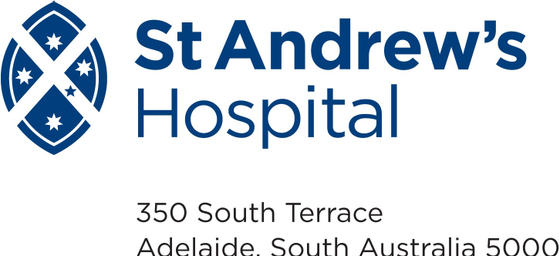
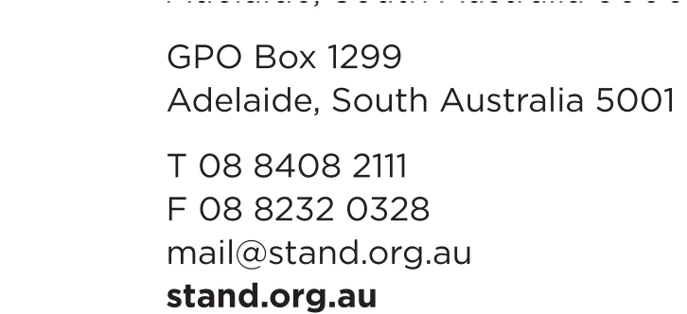











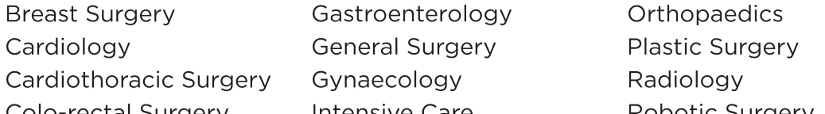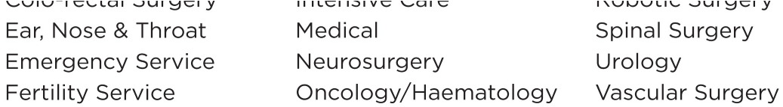

2026 Weekly unit July – Dec

St Andrew’s Hospital Clinical Pastoral Education (CPE) Centre is seeking expressions of interest from people who would like to complete a unit of CPE in second half of 2026.
Rev Leanne Jenski (known as Jenski) is the Coordinating Chaplain at St Andrew’s Hospital and CPE Centre Director.

The Course will be held weekly on Fridays from July 24th until Dec 11th
at St Andrew’s Hospital, South Terrace, Adelaide.

The first and last day will start at 8.30 and finish at 4.30.
All other days will start at 8.30am and finish 2.30pm.
We will not meet on Friday August 28th

The fee is $2250. (There is also an option to enrol through the University of Divinity for accreditation towards an award and use HECS; ask Jenski for more information.)

A CPE Unit is a total learning process of at least 400 hours (approx. 20 hours per week) of supervised learning, integrating clinical experience and practice, group and individual supervision, personal and collegial reflection, and directed critical reading and recording, including:
- 90+ hours of group work – Friday – mostly 8.30am-2.30 pm
- 10 hours of individual supervision – To be arranged when the unit starts.
- 200 hours practicum in an environment where you are providing pastoral/spiritual care. 100 hours will be the provision of face-to-face pastoral/spiritual care. The other 100 hours will be preparing to visit, debriefing, inter-disciplinary and collegial conferring, documentation, handover, etc. These 200 hours can be achieved as a pastoral student at St Andrew’s Hospital (10 hours per week) or in another setting by negotiation if you are already working or volunteering in a pastoral setting.
- 100 hours for preparation of material.

For further information, please get in touch with Jenski on 0417 863 635 or jenski@stand.org.au. Applications close 1st May 2026

For more general information about CPE visit https://santacpe.com/

What is CPE?
Clinical Pastoral Education (CPE) is education and formation for the professional work of pastoral/spiritual care. CPE uses an educational methodology that combines knowledge of theology/spirituality (what we believe), with knowledge of education (how we learn), with knowledge of the behavioural sciences (who we are as human beings). CPE’s methodology utilises the ‘action-reflection’ model of learning.

The ‘action’ component entails practical experience in the work of pastoral/spiritual care within a pastoral/spiritual care setting; this care acknowledges and attends to the human condition, particularly life’s spiritual dimensions.

The ‘reflection’ component entails the exploration, articulation and integration of the pastoral/spiritual carer’s experience, the dynamics present, and the theological/spiritual implications.

This ‘action-reflection’ process is integral to CPE students’/participants’ understanding and the formation of their pastoral/spiritual care identity and competence. CPE encourages learning from living human documents.

The specific content of a CPE Unit will depend upon the particular interests and needs of the students/ participants and the context(s) in which they offer pastoral/spiritual care. The learning process allows for the addressing of the particular learning goals that each student/participant identifies. The process balances the practical experience of pastoral/spiritual care, small group supervision/interaction, and personal individual supervision in an integrated programme of experiential and theoretical education.

